Garlic Beer Marinade for Grilled Chicken
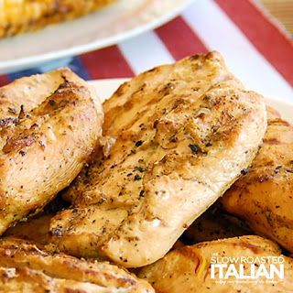
Prep Time Cook Time 45 min
2 Servings
Ingredients
1 12 ounce bottle dark ale beer
¼ cup extra virgin olive oil
6 large cloves of garlic, smashed
¼ cup lemon juice
3 tablespoons fresh basil (or 3 teaspoons dried)
2 teaspoons dried oregano
1 teaspoon dried thyme
2 teaspoons kosher salt
1 teaspoon freshly ground black pepper
4-5 lbs boneless skinless chicken breasts, trimmed and washed
Directions
- Place chicken in a 1-gallon resealable plastic bag. Set aside.
- Whisk to combine olive oil, garlic, lemon juice, basil, oregano, thyme, salt and pepper in a bowl.
- Combine 1/4 cup marinade mix and 1/2 cup beer in an airtight container. Reserve this mixture and place in the refrigerator.
- Pour remaining beer into mixture and pour over chicken. Squeeze out as much air as possible and reseal bag. Turn your bag a few times to make sure chicken is well coated with marinade. Allow chicken to marinate in refrigerator for 3 -24 hours.
- Remove chicken and reserved marinade from refrigerator and set on counter to come to room temperature, about 30 to 60 minutes.
- Preheat oven to 350 degrees.
- Pour off 1/2 of marinade, add the chicken and remaining marinade to a baking dish and bake in convection for 45 minutes (in oven 60 minutes) flipping halfway through.

